- Photograph and its specifications:
1) The photograph that will be used for the residence permit transactions must be biometric and taken according to the ICAO standards within the last six months. The photographs that are photocopied or multiplied on a computer and the ones that are not biometric will definitely not be accepted.
Your biometric photo will be checked by the system and the assessment will be made according to the images below and they will either be accepted or rejected.
a. The face and hairstyle must be centered on the photograph and completely visible. Contrast must be controlled well, details must be sharp and clear enough. The height of the face must be between 32 mm and 36 mm and comprise between 70% and 80% of the photograph.
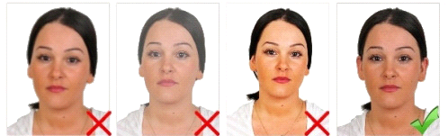
b. There must not be spots or distortion on the photograph, colours must be neutral and the photograph must reflect the natural colour of the face.
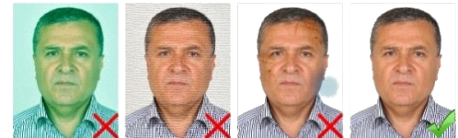
c. Your photograph must be taken while you are looking at the camera directly, eyes must be open and clearly visible, and hair must not cover the eyes.
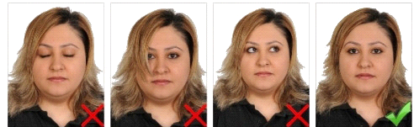
d. Head must be upright and must not be facing any other direction, person must not smile or have any other expression, and mouth must be closed. Right and left features of the face between tip of the chin and hairline must be completely visible.
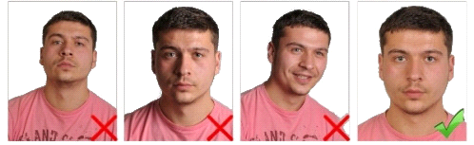
e. Background of the photograph must be without a pattern or shadow, for the ones who have dark hair it must be white and for the ones who have fair-hair it must be midtoned grey.
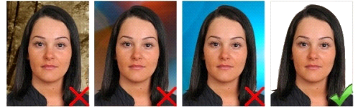
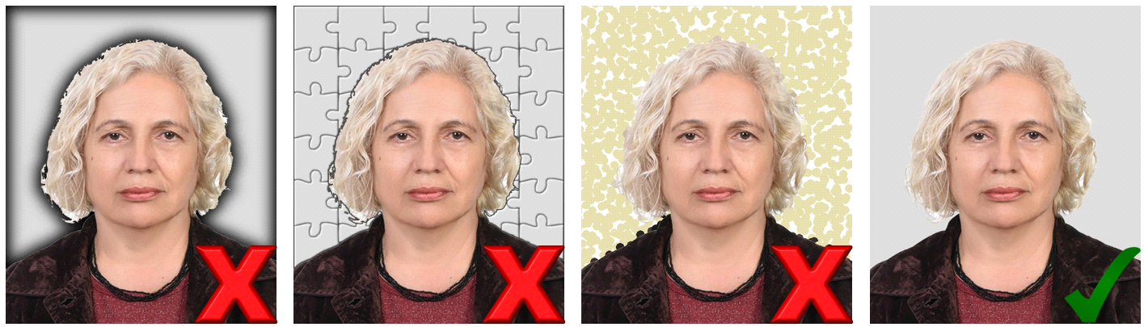
f. Light must be projected on the face equally, there must not be any reflection, shadow, or "red eye" on the photo.
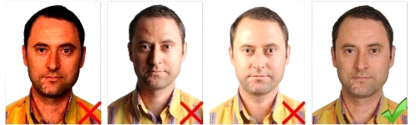
g. Eyes must be clearly visible, there must not be any reflection on the glasses, sunglasses or coloured glasses must not be worn, frame of the glasses must not cover the eyes.
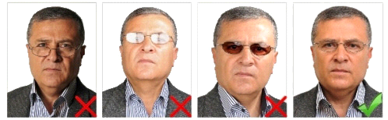
h. Except for the accessories that the person has out of necessity such as eyeglasses, objects such as hats, caps, or pipes must not be used.
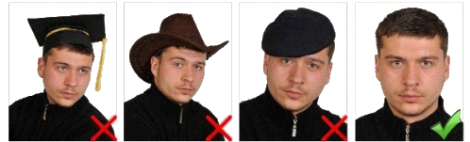
i. For the photographs of the persons who wear a head covering, the face must be visible between the tip of the chin and forehead, there must not be any shadow on the face, and the colour of the scarf must be different than the colour of the background.
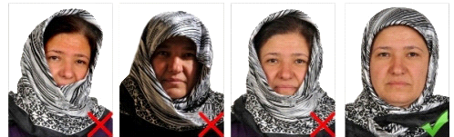
j. For the photographs of the minors there must not be anyone else or any object in the photo and also attention must be paid to the other points above.
